Xbox Storage System
If you have questions or comments, contact your account manager.

Overview
Secondary storage has become an integral part of console gaming over the last five to seven years. While the prevailing logic has been that no secondary peripheral ever sells very well or achieves critical developer support, memory unit attach rate has closed in on 1:1, and developer adoption is close to 100 percent. The reason is simple: Having reliable persistent storage dramatically expands game potential. Prior to the memory unit revolution, progress was “saved” by unlocking cryptic keys that the user could then enter (often laboriously) at the initial game screen to jump to a specific point in the game. The keys had no room for custom experience. Every user who unlocked a key jumped to the same point in the game.
Still, memory units alone are not a perfect solution. While they are roamable, they have had low capacity. While ubiquitous, developers could not rely on one being connected at title launch. Both of these limitations have, to some extent, limited the use of memory units to storing user data and some simple world state information.
With the Xbox™ video game system from Microsoft, the next revolution in secondary storage has arrived. In addition to removable memory units, the Xbox console will ship with a large internal hard disk in every box. This simple addition opens up a new world of options for both users and game developers. The size (several magnitudes larger than a memory unit) and constant presence of the storage system will increase the possibilities for immersion.
However, along with additional possibilities, the more complex storage system available on Xbox raises potential problems. It must be handled fundamentally differently than on the computer platform or risk the potential of bringing the many computer game headaches into the living room. This document describes the support for the Xbox storage system and details how this support addresses the complexity while providing an enhanced platform for game developers.
Storage System Goals
The following goals drive the design of the Xbox storage system:
- Robust and reliable. An overriding goal. Storage just works. In demanding conditions, the system must, as much as possible, ensure that it behaves predictably. It must do this without resorting to time-consuming and arcane self-maintenance (such as Scandisk). The file system should not become corrupted because the power cord was removed or a memory unit was yanked.
- Simple and transparent to the user. The user benefits from the additional possibilities enabled by the hard disk but is not burdened with management headaches. When interaction is required, such as when managing save games and user data, the system should organize data so that it is meaningful to the user and devoid of implementation references. Save games should be managed, not files. If the user will not understand a piece of data, where it came from, or what it is used for, the user should not be forced to manage that data.
- Simple to use by developers. The system should use well-known (and well-tested) libraries and provide a simple and defined structure. Developers should not have to jump through artificial or convoluted hoops to use storage in a game. Restrictions should be unambiguous and easily tested.
The following are non-goals of the system:
- Storage connectivity. Each storage space on an Xbox console is local to that Xbox console. There will be no concept of extending the storage space to include that of other connected Xbox consoles or computers.
- Full low level access. Except inside the utility area, developers will be constrained to use the file system libraries to access stored data.
- Shared system code files. Xbox will not allow use of the storage system to share code between titles.
Storage Domain
Three main stores are available for the initial release of the Xbox console: The DVD player, the Xbox hard disk, and memory units.
The DVD Player
The DVD player is the main read-only store on the Xbox console. All titles are loaded from DVD; future Xbox expansion will be based on DVD, and so on. Without the DVD player, the value of the Xbox console diminishes significantly. Because it is read-only, dealing with the player is relatively simple. However, it is worth noting that the drive is a constant angular velocity (CAV) drive. Because of this, DVD layout is extremely important. The difference in streaming speed from the fastest to the slowest parts of the disk is more than 2×.
Therefore, the Xbox Development Kits (XDKs) need emulation code that properly simulates this type of drive before the real hardware is available and sufficient tools to allow title developers to lay out code and content on the DVD to maximize performance.
Due to the large capacity of the media, titles will also be able to save multiple copies of files to disk, improving robustness through redundancy. However, it is up to the title to implement this.
It would be useful for a title to be able to stream data simultaneously from the DVD to memory and to the hard disk. Unfortunately, this will not be possible. Both the DVD and the hard disk share the same Integrated Device Electronics (IDE) channel. Even if the devices were on separate channels, there is no support in the standard for streaming from device to device without using intermediary memory buffers.
The Xbox Hard Disk
The preeminent and most heavily used store on Xbox is the built-in hard disk. This store is used extensively to enhance game play. It is the focus of most of the storage story because it is fast, large, and always available. Every Xbox console will have a hard disk. By contrast, the projected attach rates of memory units are much smaller.
If the Xbox hard disk is corrupted, no title will work. The hard disk is so integrated into the Xbox video game system and title functionality that if it does not function correctly, the box will have to be shut down until corrective measures can be taken. A situation in which some titles continue to operate while others fail (probably with cryptic computer-style error messages) is not acceptable. An integral part of the boot sequence is the spin up and verification of hard disk functionality. Note that it is not possible to have a perfect verification scheme on Xbox (nor does one exist on any personal computer). Undetected corruption may still cause title problems, and game developers should write code that expects media errors and handles them gracefully.
Memory Units
The Xbox memory units complete the local game storage picture. Memory units are sold separately from the Xbox console and are connected to the Xbox console through controllers. The main Xbox controller will have expansion slots for two memory units. A total of four of these controllers can be attached to the system at one time, giving a total of eight potential memory units on the system. No device will be licensed that allows more than two memory units, although devices that have fewer expansion slots may be available. Titles will be responsible for enumerating the memory units available during gameplay (using Xbox Title Libraries calls).
File System Overview
There are two separate file systems on the Xbox, one for the DVD drive and one for the read/write storage areas. UDFX is a derivative of the UDFS file system for the DVD drive. FATX is a derivative of the FAT32 file system for other storage mediums, such as the hard drive and memory units. Both of these file systems will function significantly different than their PC counterparts.
Since these file systems are designed for a specific purpose game console instead of a general-purpose personal computer, the functionality will be much more tightly coupled to the needs of the Xbox. Many features that are taken for granted in PCs will simply not be available. The Xbox Developers Kit will contain an extensive section detailing the differences between the file systems. Additionally, performance (especially write performance) will not be as fast as on the personal computer. In many cases, the file system will err on the side of writing data, more often than absolutely necessary in order to achieve the reliability goals mentioned above. The file systems will be significantly smaller and much more deterministic performance characteristics than the PC versions.

The file system cache used by both FATX and UDFX is significantly different:
- Cache size is static. It will not grow dynamically as it needs additional pages. Note that there will be a mechanism for a title to shrink or grow the cache size to tune performance.
- The cache can be sized between zero and 8M. At zero K, any file system call that needs to touch a directory will probably fail with "out of memory" but you could still stream from a UDF file. A single file system call (CreateFile, ReadFile, WriteFile, etc) will map a maximum of one cache buffer at a time, so you can do anything with the file system if there's a single page given to the cache.
- All writes are automatically write-through. There is no background lazy writer thread. Writes back to the hard drive may be done in 512 byte sector units instead of full page writes. (example: directory entry updates only write out one sector).
The following differences appear in FATX and UDFX:
FATX:
- File Names are limited to the 8.3 format.
- No characters above 0x7F are allowed.
- Normal FAT restrictions remain for characters between 0x00 and 0x7F.
- Writes are serialized at the driver level.
UDFX:
- Sharing mode in CreateFile is ignored.
- The creation, last modified, and last accessed dates are all set to the modify time from the "information control block" from the base ISO 13346 file system. There are UDF extensions to store creation and last accessed dates, but they are unused on Xbox
- UNICODE characters cannot be used in file names.
The following changes have been made to the file system APIs:
- CreateFile paths are always case-insensitive.
- FindFirst/FindNext operate with the following changes:
- The “.” and “..” directories are never returned.
- cAlternateFileData in the WIN32_FIND_DATA structure is not filled in.
- Patterns follow DOS style wildcard specifications only:
- “*<NULL>” matches zero or more characters at the end of a file name.
- “*.” Matches zero or more characters at the beginning of the next extension.

- MoveFile will not move a file between two different partitions. Use MoveFileEx instead if you need this. Additionally, MoveFile does not currently support moving directories from one place to another on the same volume. It is anticipated that this restriction will be removed.
- WriteFile supports synchronous I/O only. Opening the file for asynchronous I/O and using WriteFileEx will work, but the call will always block.

Storage Access
The storage system compartmentalizes the total storage space into some number of conceptual regions. The system implements appropriate policies for caching, visibility, and space limitations for each specific region.
The system also defines various classes of storage clients. Each storage client class is given specific access rights to regions. All clients in a specific class share the same set of access privileges. When a client requires storage, it is presented with a view of each of the regions that it can access as defined by its client class.
Note that the concept of regions is separate from that of partitions. Some regions may span multiple partitions, while several regions may share a single partition and others may be outside the file system altogether. Access privileges are defined in both code and policy.
Storage Clients on Xbox
Two classes of clients are defined on Xbox: title clients and system clients. As the name implies, the population of title clients consists of all of the possible Xbox titles (including demos and other special versions). System clients are more diverse and consist of the raw kernel, the Xbox Dashboard, recovery and configuration disks, and others.
Storage Regions of Xbox
Xbox has five defined regions: settings, user data, utility area, title data, and the Xbox Dashboard code.
Settings
The settings region will be used to store all system state and configuration information necessary for Xbox. No other process will be able to access this region through the namespace. Specialized libraries are used to access this data.
Because of the importance of the data stored in this region, neither user initiated nor automatic space reclamation methods will be available. Xbox system software and the Xbox Dashboard will manage this space directly.

Visibility | System clients only
Location | Outside file system, hard disk only
Use | Global Xbox configuration data
User Data
The user data region will be used to store all user data on the system. Primarily, this consists of user save games. The Xbox Dashboard will also save data in this area in future releases of the Xdash software.
User data is stored both on the data partition of the Xbox hard disk and on all memory units. While other regions exist on the hard disk, user data is the only region that exists on memory units.
The data in this region is organized into a specific hierarchy. All titles must conform to this hierarchy to pass certification. For more details on this hierarchy, see the Save Game section.
Titles will be certified to use no more than 8 megabytes (MB) for one save game. This certification requirement will be used to ensure good roamability between the hard disk and the memory units.

Visibility | System and title clients only
Location | Hard disk data partition and all memory units
Use | User save data (save games and so on)
Utility Area
Titles may use the utility partition of the drive in any way they wish. No restrictions will be placed upon titles in this section.

The utility area itself spans three different partitions, each 750 MB in size. Titles are assigned one of these partitions on a least-recently-used basis. Therefore, if a title has previously saved data on a utility partition, and that partition has not been assigned to another title in the interim, the title will receive back the same partition (and thus access to any of its previously saved data). If not, a new partition will be assigned based on LRU aging.
Note that utility space has multiple uses besides the caching of perfectly re-creatable data. Titles can also use this utility space to store any data that can be deleted between gameplay sessions. Some titles may, for instance, use this area to implement virtual memory or for in-game scratch space. No prescribed use of this area is mandated by the storage design.
Titles will also have several other options concerning the utility area. Based on options specified at build time, they will be able to either automatically mount or postpone mounting of this area. Additionally, they will be able to specify whether or not the utility area should be automatically formatted when mounted (for example, the case in which the title uses the space simply for scratch reasons, not other utility purposes), or if the data should be kept until later. Finally, the title will be able to mount and/or format its utility partition at a later time by calling XMountUtilityDrive. See the “Reference” section of the XDK for more details.

Visibility | Title clients only
Location | Hard disk utility partitions
Use | Generic title use
Title Storage
The final title-exposed region is reserved for title persistent data. As opposed to user data, in which users typically decide when and what is stored (for example, explicitly choosing to save a game), persistent storage is created at various times, either with or without the explicit knowledge of the user.
Examples of the types of data that might be stored in persistent storage include updated player rosters, new levels, and bullet holes, skid marks, and other user changes. As time progresses and title developers become accustomed to having the hard disk as a built-in option, this region will be the focal point of the next level of immersion in games.
The persistent storage region has little format. Unlike user data, in which strict controls are maintained over the format and use of space, this region is left mostly to the individual title developers to define. Therefore, the data in this region will not generally be browsable from within the Xbox Dashboard. The data in this region will be managed all or nothing—“I no longer play this game. Trash it.”
Future revisions of the XDK may contain additional details on using the title data area to store downloadable content.

Visibility | Title clients only
Location | Hard disk data partition
Use | Title persistent storage
The Xbox Dashboard Code
Xbox will be the first console to have system executable code living outside of read-only memory (ROM). The Xbox Dashboard code will reside on the Xbox hard disk and will be loaded by the ROM when no DVD title is present. This code needs to be protected as much as possible from problems in the other region. Because of this, the Xbox Dashboard and its copy of the Xbox Title Libraries (XTL) will reside on a nonstandard partition separate from the rest of the regions of the Xbox hard disk. Outside of major disk failures or rogue code either trouncing partition tables or writing to the disk using low-level function calls, the Dashboard code should be safe from software-based file system failures. Unfortunately, this approach limits growth. The Dashboard will not be able to grow beyond the size allocated to this partition. We will live with this restriction. The size of this partition will remain unknown until the working Dashboard and XTL are developed.

Visibility | System only
Location | Hard disk Dashboard partition
Use | Dashboard code only
Accessing Storage Regions
Storage clients access data regions through the namespace provided by the system. Due to the design of the system (all titles run at Ring 0, use of system software components is generally optional, and so on) it is not possible to fully protect regions and portions of regions outside of a particular client’s namespace. Therefore, Xbox relies only upon “weak” sandboxing.
Weak Sandboxing
Basic methods of maintaining title and client separation are implemented as weak sandboxing. The namespace for a title is instantiated by creating drive letters for the areas that a title needs to access. When a title is first launched on Xbox, appropriate subdirectories are created within each of the regions that the title needs to access (utility, user data, title storage). The symbolic links created will link to the specific title’s subdirectory (as opposed to the root of the region). Therefore, only that title’s data will be available—there are no symbolic links in the namespace for other titles. This is somewhat akin to the “SUBST” command in MS-DOS except that, additionally, the original path will not work. There will be no symbolic links for the roots of regions.
There will be certification tests to ensure that the sandboxing is followed.
Namespace Defined
Each region of the hard disk, each memory unit location, and the DVD player will be represented with a corresponding drive letter in the namespace. These drive letters will be hard coded and will not change over the life of the Xbox video game system. Drive letters not used will be reserved for further expansion.
Instead of drive letters, which many find galling, Universal Naming Convention (UNC) paths could have been used. Also, the file system conceivably could have been changed enough so that it was rooted with virtual subdirectories, and so on.
UNC directories are problematic because the code that creates the partitioning of the namespace would then interfere with some valid uses of UNC paths (drivers, and so on). In general, UNC paths are a lower level concept than the paths used in MS-DOS. Placing the code in the MS-DOS path translation layer somewhat reduces the risk of inducing bugs or other undesirable consequences.
In addition, creating a new style of rooted path system would entail significant work and is not justifiable simply to remove the “warts” of drive letters.
Finally, for portability reasons, using standard drive letter paths is attractive. A great amount of path cracking code in the world looks for things such as drive letters. Developers who work on both the personal computer and Xbox platform will be more comfortable with the drive letter paths, and their code will be much easier to port.
Drive Letter Mapping
Table 1 lists the drive letter mapping assignments used to demark the storage namespace in Xbox.
Notes:
- titleId refers to the assigned title identifier for a particular game. See the next section, Title Identifiers, for details on this identifier.
- X: and Y: are reserved mappable drive letters. These drive letters are used to map in data from a related title using the XMapUnmapAlternateTitle function, available in future releases of the XDK.

Table 1 Drive letter mapping table
Drive Letter | Mapping | Notes
A: | None | Unused
B: | None | Unused
C: | None | Unused
D: | DVD Player
E: | \DEVKIT | Used to launch titles off of the development kit hard drive. Only visible from development machine connected to the Xbox.
F: | MU root\titleId | Port 1 Slot 1 MU
G: | MU root\titleId | Port 1 Slot 2 MU
H: | MU root\titleId | Port 2 Slot 1 MU
I: | MU root\titleId | Port 2 Slot 2 MU
J: | MU root\titleId | Port 3 Slot 1 MU
K: | MU root\titleId | Port 3 Slot 2 MU
L: | MU root\titleId | Port 4 Slot 1 MU
M: | MU root\titleId | Port 4 Slot 2 MU
T: | \tdata\titleId | Title data
U: | \udata\titleId | User data
W: | {mappable} | Used to map another title’s user data region (either from an MU or from the disk).
X: | {mappable} | Used to map another title’s persistent data region.
Z: | \utilitypartition | Title’s utility area. Note that this drive letter maps to one of three partitions.

The system configuration region is not assigned a drive letter in the preceding scheme. This is by design. System configuration data is not accessible to titles except through specially designed configuration libraries.
Title Identifiers
Title identifiers on Xbox will have a unique 32-bit identifier associated with them. This unique identifier will be used to create the title subdirectories in the various storage regions. The directory name is simply the eight-character hex representation of the title identifier.
Mapping Related Titles
Note: Not available in the December release. During the lifetime of the Xbox video game system, many games will ship as sequels or peers of previously released titles. There are many compelling reasons to allow some method for the new release to use data from the older game: continuation of character and party data, importing customized playbooks, cars, and so on. To enable this scenario, by using the XMountUnmountAlternateTitle call (available in future versions of the XDK), developers will be able to mount any title with the same publisher identifier (for example, Microsoft-published games can map in other Microsoft published games). Additionally, it will be possible to map other publisher’s titles in through special fields in the Xbox executable (XE; subject to certification approval).
Only one user partition can be mounted at a time. This restriction removes some overhead from the process and is sufficient for the needs outlined here—titles can simply enumerate serially through the potential user data locations, mounting each in turn.
Identifying User Data Locations
Unlike the other data regions, which are either always present or never present, a varying number of user data regions will be present during the lifetime of a title game session. In addition to the hard disk user data region, up to eight other memory unit–based user data regions may be present.
Memory units (MUs) are Xbox peripherals (detailed in the “Xbox Peripherals” specification) that connect to Xbox controllers. Titles can query the connected state of memory units using XGetDevices and XGetDeviceChanges, respectively.
Using the information returned from XGetDevices and XGetDeviceChanges, developers can then mount a memory unit into the file system using the XMountMU function and, when finished, use the XUnmountMU function to reclaim the resources used. As specified in the preceding table, each memory unit is assigned a fixed drive letter. However, these drive letters are not mapped until the memory unit is mounted into the file system.
Launching Titles on the Development Kit Hard Drive
During the early development cycle of games on the Xbox system software, title developers will need some method of launching their games without burning CDs or DVDs. Xbox Development Kits will ensure this is possible both through a hard drive directory not available on non-development systems and through DVD emulation hardware.
Title developers may place data in the directory C:\DEVKIT. If titles are launched via the hard drive, this will be mapped both to the E: drive (viewable in the debugger only) and to the normal D: drive (normal location of the DVD player). Titles can therefore always be designed as if they are running from a DVD drive. Note that unlike the preferable DVD emulator, this area behaves like a normal hard drive. Title developers must be careful not to rely on the performance characteristics of this area when designing their games.
Information on the DVD emulator will be included in future releases of the documentation, as more information becomes available.

Using the User Data Regions
Users will perceive much of the storage on Xbox as save games storage. This section details how save games are defined, organized, and used on Xbox.
Save Games
The save game support in the XTL is designed to support the following goals:
- A simple and extensible mechanism for titles to create and manage save game files
- Uniform methodology for associating metadata with a save game
- Symmetric support for saving games to the Xbox hard disk and to Xbox memory units.
This support is not designed to:
- Provide a general complex black box save game library
- Provide symmetric support for saving locally and online
Save Game Defined
Throughout this document, the term save game is used in a variety of contexts. Save game is a generic term for the types of data that will be saved by titles using the functionality described in this specification. Specifically, titles often save the following types of data:
- Keys for unlocking new/secret game features—examples include unlocking new characters in most fighter games or new cars in most racing games.
- Game progress—the standard save game concept. Saving the current game state so that you can resume from that point later.
- Game customizations—saving player-customized game data. This includes assembling a hand-tuned football team or updating your car.
- High scores and statistics—the earliest and simplest example of save game data. The concept of a high-score table is well known and understood in many, many games. In many cases, this concept extends beyond scoring and encompasses more game-specific statistics.
- Game replays—saving a replay of the game action. Examples include almost all recent or current racing games.
- Screen shots—similar to game replays, a way of remembering the game action at a particular point. Static screens show the action at a specific moment.
- Environmental changes—saving skid marks, bullet holes, and other environmental data.
The preceding list is a catalog of current save game data types. This list will grow over time.
Unique Challenges of Save Game Support
Xbox is a console. However, it is unique among both personal computers and consoles because of the variation of storage mediums available out of the box for saving user game data. Specifically, users must choose between two options, each with variant characteristics in terms of storage, access speed, and connectivity.
No console has ever exposed support to save games to anything other than removable media (memory units). Similarly, although a wide variety of storage devices exist for personal computers (floppy disk, hard disk, jazz drive, tape, and so on), the overwhelming majority of computer gamers use the hard disk exclusively for saving game data. Some online games (especially massive multiplayer online role-playing games, or MMORPGs) support saving game data to the Web; however, this is not a general option.
In the Xbox video game system, the hard disk and memory units will be presented on equal footing as available storage spaces. The users then must choose which of these stores to use based on a variety of factors.
The usability implications of this amount of choice should not be overestimated. With this expansion of capabilities and features comes a corresponding increase in complexity. One of the main strong points of consoles has always been simplicity. Maintaining that simplicity while expanding the feature set is always a challenge.
Some examples of the various choices users will need to make (explicitly and implicitly) to choose a storage location:
- Is this my Xbox console?

- Is there enough space available on my chosen device?
- Do I want to take this save with me when I play on another Xbox console?
Furthermore, because there is no concept of common dialogs on Xbox, the individual titles must explain and present the available choices to a user when saving a game. Through certification, recommendation, and reference implementation, the Xbox team must ensure that the basic concepts underlying these choices (base graphical representations, naming, and so on) are consistent across titles while still allowing titles to craft the aural and visual user experience to match the particular game.
Finally, the fact that there are multiple types of stores, some not explicitly linked to save games, introduces significant chances for problems. If, for example, a save game relies explicitly on data stored in the title’s persistent storage area on the drive (for instance, a new level or downloaded extras), significant problems may arise if that save game is then copied to a memory unit and taken to an Xbox console on which those additions do not exist. Unfortunately, the fact that certification happens long before new extras are available will make this difficult to catch.
Save Game Design
This section describes the design of save game support on Xbox.
Basic Concepts
Figures 1 and 2 illustrate the save game model on Xbox. Each device that can hold save game data distributes the data into a unique container for each title. At any given time, a collection of these storage devices is connected to the Xbox console. This set will always include the hard disk and may additionally include some number of Xbox memory units. On memory units and the hard disk, the title containers are represented by unique directories.
The view in figure 1 shows a snapshot of an Xbox gaming session. In addition to the hard disk, four memory units are connected. Each of these stores has some collection of saved games, organized by title. It is important to note that there is no guarantee that a game saved on one of these stores (except for the Xbox hard disk) has ever been played on the Xbox console to which they are currently connected. This has implications regarding the naming of title directories and the distribution of title metadata.
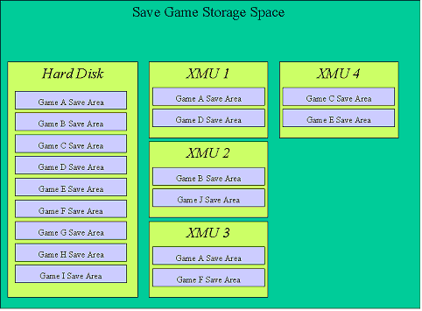
Figure 1 Save game storage space model (not to scale)
Figure 2 presents a zoomed in view of a particular title’s save game area on a specific device. Each title can have associated common metadata that applies to all associated save games on that device (see figure 2). Each save game present in a title’s saved area is a container that can hold one or more data files (game specific and opaque to the Xbox video game system) as well as one or more metadata files (used by games, the XTL, and the Xbox Dashboard). On local storage, common metadata are simply files in the root directory of the title. Save games are unique named directories under this root that contain the associated data and metadata files.

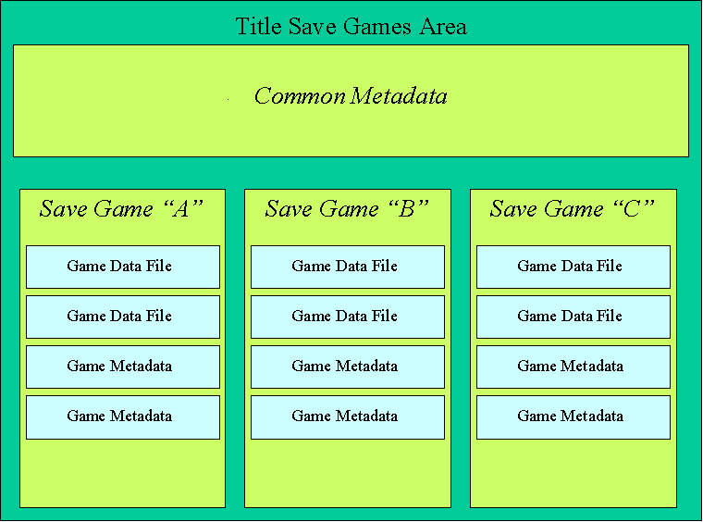
Figure 2 Title save games area model

Save Game Metadata
Over the life of the Xbox video game system, various types of metadata will be defined. Titles can then optionally associate this metadata with a saved game. Metadata lives in the save game directory, and each metadata file will have the standard extension .xbx. To ensure that future named .xbx files do not collide with the title’s save files, titles should not create proprietary .xbx files. Most likely, the year one Xbox console will support various .xbx files to display models and textures associated with save games inside the default title.
In addition to creating metadata within a particular save game, titles can save common metadata that applies to all save games on a particular device. All .xbx files saved to a particular title’s root directory in the save game region of a device are considered common metadata files. Thus, a title that associates a particular model with all save games could save space and time by saving the metadata to the title’s root directory. It is the responsibility of the game developer to ensure that common metadata exists (if needed) when saving a game to a device.
If a user copies a game from one device to another from within the Xbox Dashboard, appropriate common metadata also will be transferred if and only if it does not already exist on the target device.
Creating and Managing Save Games
For local storage, the atomic unit of a save game is a subdirectory within the root of a title’s save game region on a specific device. The system software and Dashboard move and delete data only at the subdirectory level. This simple system imposes enough structure to manage data out-of-title while still allowing maximal freedom by the title developer in determining exact format and content of save games.
Within each subdirectory, a title can write as much data as necessary as well as additional metadata files that will be used by the Dashboard to manage the system. Data within the subdirectories is written using the standard file I/O functions (CreateFile, ReadFile, WriteFile, and so on).
To simplify some of the tasks involved in creating and managing save games, several functions will be exported for title developer use. These functions are presented in table 2 for reference.
These functions are useful for tasks such as creating and deleting save games as well as enumerating the available save games on a particular save location. These functions, in most respects, are simple wrappers above existing Microsoft® Win32® functions so that they fit more closely with the general structure of save games on Xbox.
Table 2 Specific save game functions in Xbox
Function Name | Purpose
XCreateSaveGame | Create a new save game
XFindFirstSaveGame | Begin an enumeration of a title’s save games on a specific device
XFindNextSaveGame | Continue an enumeration begun with XFindFirstSaveGame
XFindClose | Terminate a save game enumeration
XDeleteSaveGame | Delete a save game on a specific device
Save Game Space Limitations
A large disparity exists between the potential space available on the Xbox hard disk and on a given memory unit. However, users expect to be able to roam data freely between memory units and the hard disk. Because of this, no save game may exceed the size of a formatted empty memory unit (around 8 MB). This space limitation will be enforced through certification.
Personalizing Memory Units

Note: This feature will not be available in the December release. The process of selecting from a multitude of potential save locations is generally bad on most existing console games. While some games simply punt the problem and require that a memory unit be in the first slot on the first controller, others present a bewildering drop down list, such as “MUA1, MUA2, MUA3, MUA4...” At the very least, it takes a few moments to correlate the arcane terminology with the real world connection environment.
On Xbox, it will be possible to personalize a memory unit with a descriptive string so that the unit can be more easily recognized in such selection lists.
Titles will be able to use this information to display more usable lists: “Save to Marc’s Games,” “Jeff’s Junk,” and so on.
This special file will be placed on the memory unit at format time (usually on the factory floor, unless the catastrophic recovery is used later). Within the Xbox Dashboard, users will be able to change the default name in the file to personalize it to their tastes.
Users will be able to use any available characters within the Dashboard (including Katakana, Hiragana, extended European characters, and so forth). Therefore, some games may not be able to display the name with their font support. This trade-off between personalization flexibility and general support is unfortunate.

Using the Title Storage Region
As mentioned earlier, titles use title storage to maintain data across game sessions without the danger of the data being deleted (as in utility areas) and without necessarily associating the data with a specific save game (as in user data). Titles will use this region for a variety of purposes, and in general, there are few constraints on how the space should be used and managed.
The goals for title storage include the following:
- Lasting storage for general use by titles, outside of save game data.
- Manageable episodic content storage
- Branding storage
- Backing store for music playback
The following are non-goals of title storage:
- Roamability of storage
- Detailed user management of all data (outside episodic content)
Title Data Layout
At launch, a title (or the Xbox Dashboard) is provided a drive letter mapped to its specific area within the title data region. Underneath this root is a prescribed subdirectory, EPISODIC, for storage of episodic content.
Outside of this, developers are free to use this space as they see fit: creating additional subdirectories, adding content, and so on. Except for the data within the extras directory, none of the data is manageable from the Xbox Dashboard. To clean up this space out-of-title, users must delete all storage associated with a game.
Episodic Content
Episodic content is expected to be a huge feature of Xbox games. Gamers will likely receive updates to games through various mechanisms, including online download and subscription CDs. Full details of the episodic content story for Xbox will be presented in a future specification. This section deals only with the storage implications and how they impact the design of this feature.
As a result of the high priority being placed upon episodic content, it is necessary to impose some storage standards for this area. With new content being available on a monthly (or even more frequent) basis, episodic content could easily dominate the drive space of an Xbox console. Therefore, the Xbox Dashboard needs to be able to identify and manage this space.
As stated earlier, all episodic content for a particular title is stored under the title’s root title data directory in the EPISODIC subdirectory. Underneath this directory, borrowing from the model used for save game management, each piece of episodic content is a subdirectory. When episodic content is downloaded to the game system, it will be placed in its specific subdirectory. The Dashboard will manage the data using this atomic unit. Under each directory, there will be metadata files that describe the data for the Dashboard (text name and descriptions, images, and so on) and whatever content files the game defines.
This scheme has architectural implications for developers who use episodic content. Multiple episodic content directories cannot share data; each directory needs to rely only on the data contained in its particular subdirectory. And games should not move files from the original directories to other areas of persistent data. These steps, while limiting, preserve the manageability of this storage area.
Title Metadata
In the root directory of a title’s title data, specific metadata files are stored to brand a title’s game area within the Xbox Dashboard. These metadata files provide the following:
- A branding image or model for the background of the title game area
- Descriptive data for defining the title area
- URLs to specific Xbox Zone data, and so on
For more information on title metadata, please refer to the “Xbox Dashboard” specification.
Data Storage Flowchart
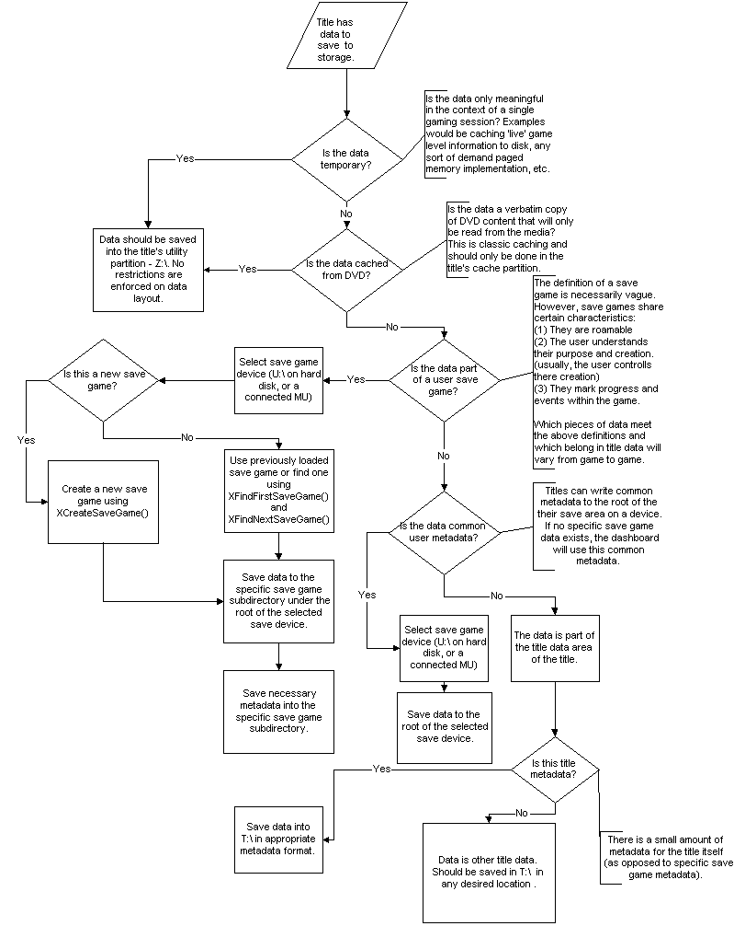

- Using the Utility Area
The utility area on Xbox comprises three separate partitions and is the simplest to use and manage of all of the storage regions in Xbox. The system needs no information about how the data is used, and titles have complete use of an entire partition, removing the possibility of corrupting other title’s data.
The three partitions of the utility area are assigned to titles on a modified LRU basis. This section provides additional details on the management of these partitions.
Utility Area Options
Titles have a number of options to use for deploying utility areas—both at build time and at run time:
- At build time, titles can choose to have the utility partition mounted at title launch, or not.
- At build time, if the title has chosen to have a utility partition automatically mounted, it can either have the utility partition formatted automatically, or not.
- At run time, if not mounted, a title can have a partition mounted.
- At run time, during mounting, a title can choose to have the partition formatted.
These settings allow titles that do not need utility space not to incur the overhead of mounting the partition. Similarly, if the title needs the partition only as scratch space, not general utility, it can ensure that it always gets the partition in a clean, known state.
Partition Assignment
Xbox maintains some state within the configuration region to keep track of details such as title partition use and last use date. If a title does not mount a utility partition, it is never marked as having been used. Similarly, if a title specifies at build time that the space should be formatted at title load, the utility area is never marked as in-use.
When a utility partition needs to be assigned to a title, the following algorithm is used:
- If there is a utility partition that was last used by that title, that partition is assigned.
- If there is a utility partition that is not in use by any title, that partition is assigned.
- The partition used least recently is assigned.
Utility Area Use
This will not be available in the December release. Because the rest of the hard disk is protected from a title’s use of a utility area by partitioning, a title can use raw I/O to write to the partition below the file system level. However, titles must use the IDE driver on Xbox—they may not write directly to the hardware. Titles can use this ability to implement alternate database/file systems that use this partition as backing store.

Music Playback
This will not be available in the December release.
Xbox does not support replacing a game disk with an audio CD to do Red Book streaming of audio within a game. However, Xbox has a much more powerful mechanism for allowing games to play back some number of prerecorded songs off of the hard disk. Within the Xbox Dashboard, a user can rip songs off of CDs and associate them with playlists. Thereafter, titles can take advantage of these playlists to play the user’s selected music.
Use of the Xbox console as a personal jukebox is not a goal of the music playback support; the implementation is keyed to managing songs for in-game playback. This section deals only with the storage back-end issues. For more information about music playback, see the “Xbox Dashboard” specification.
Playback Storage
Music is stored in Microsoft® Windows Media™ Audio (WMA) format on the Xbox hard disk inside the Xbox Dashboard’s persistent data. This data is not roamable by design; the music can be used only on the Xbox console on which the music was originally recorded.
Audio files are stored in a flat list under the /MUSIC directory of the root of the Dashboard’s persistent storage. Each file is named using an eight-character hex identifier to ensure uniqueness. Actual song title and album data is stored within the standard WMA fields. Additionally, a reference count field determines how many playlists reference the file.
Users manipulate playlists of songs to manage songs. Games always use a playlist, never individual songs, as the basis of playback. Each playlist is a subdirectory underneath the /MUSIC directory containing a data file identifying which of the songs in the /MUSIC directory belongs to that playlist.
Using Playlists Within Titles
The XTL provides a simple interface for titles to retrieve user playlists and play songs. These functions are summarized in table 3. Note that these functions provide access only to the WMA files. WMA playback is still the responsibility of the title.

Table 3 Playlist functions in Xbox
Function Name | Purpose
XPlayListFindFirst | Finds the first playlist on the Xbox console
XPlayListFindNext | Finds the next playlist on the Xbox console
XPlayListFindClose | Aborts an in-progress playlist enumeration
XPlayListGetFirstSong | Returns the path of the first WMA file of the specified playlist
XPlayListGetNextSong | Returns the path of the next WMA file of the specified playlist
XPlayListDone | Signifies that the title is finished retrieving songs from the specified playlist

User Nicknames

Users are prompted for names while playing game titles for a variety of reasons. A user may have achieved a high score, created a new save game, found a new character, reached a specific milestone, and so on. Many users tend to gravitate towards either one specific nickname (Doughboy), or a small set (SupahKillah, Taximan, BustAMovah, DanceDanceGahd).
Because they are needed in various places, and because the text must be entered laboriously through a virtual keyboard, repeated entry can become annoying. Xbox provides a mechanism designed to allow titles to guess at a likely set of nicknames and present those choices to the end user. While not perfect, the system enables the user to quickly choose a preferred nickname in many situations.
Note that this system of nicknames has nothing to do with online identities. This system behaves as a simple cache of data to aid in entering text. Online identities are complex concepts used for authentication and tracking.
The System
The above nickname system is implemented by using the Xbox hard disk as a cooperative cache of old nicknames. Through simple libraries, titles can enumerate the current list of nicknames in the cache and add new ones to the list.
Storage
The cache of nicknames is stored in the root of user data on the hard drive, below the user roots of each game title. The Unicode file is a fixed size and will always exist. There will never be any storage problems caused by this file exceeding its expected size and therefore causing a title to run out of disk space.
The tradeoff for this predictability is a loss in its expandability. The file can hold only a limited number of nicknames. In the event that a new nickname is added to an already full cache, the oldest nickname will be dropped. The exact number of nicknames the file can hold is variable and depends on the number of games that share a common nickname. In practice, there will be enough room for a large cache of 20 or more names.
Additionally, adding to the predictability of nickname storage (as well as providing a meaningful length assumption for game developers), all nicknames are limited to 31 characters plus a null character as defined in the header files by MAX_IDENTITYNAME.
Case Sensitivity
Case sensitivity is surprisingly important in nicknames. Any quick survey of online leader boards or chat rooms will reveal a huge assortment of naming schemes. Capitals are used to delineate words, to distinguish clans, and just to look “cool.” The Xbox video game system will honor the case sensitivity of the nickname when an application adds it to the cache. In the case where the nickname is being re-added, the cache can honor the capitalization of the newest entry based on the value of fPreserveCase in the XSetNickname function.

Roaming Nicknames
There is no support for roaming nicknames to memory units or other storage devices. The nickname cache is strictly local to a specific Xbox console.

Miscellaneous Storage Issues
This section details issues regarding insufficient storage space, read/write performance, and rental game systems.
Storage Space
In a perfect world, the game will have all of the storage space it needs. However, under practical playing conditions, titles will encounter situations in which space is insufficient for their needs.
Developers should be aware of how much space particular pieces of their game will need and should budget accordingly. The game should check the relevant regions for that space at title-launch. If space is insufficient, especially for critical needs, the game should warn the user that specific features would be unavailable unless they free sufficient space. If the user wishes to free space, the game can reboot into the Xbox Dashboard to allow the user to manage space globally.
If at all possible, users should not be presented with an “out of space” condition at a critical juncture of the game.
Performance
Windows operating systems typically use expansive caching strategies to improve the performance of the file system. Writing data to a file typically does not result in that data being committed to disk. Instead, a writer thread opportunistically writes data asynchronously from the application.
On Xbox, this sort of caching is sub-optimal. First, it results in large windows in which the data on the disk is not current, increasing the chance of corruption because of an immediate power-off. Second, the amount of system random access memory (RAM) needed to maintain a good cache is very large.
Therefore, storage in Xbox is write-through in nature—file writes are committed to storage immediately. The price of this, of course, is lower general performance than a fully cached system.
There will be samples that describe how to optimize read/write performance on Xbox file systems for each supported device, as well as adjust the size of the cache as needed.
Xbox Video Game System Rental Considerations
It is almost a certainty that, during the lifetime of the Xbox video game system, various retail outlets will rent both the console and games. This raises numerous questions concerning hard disk storage: Is storage reclaimed between rentals, or does it carry over? How does storage of online connectivity information get reset?
Likely, we will provide retailers with a full recovery disk for quickly resetting the machine to a known state. However, there is no guarantee that this disk will be used. For storage, it is acceptable to have state remain on the disk. If the disk is full, a user can clean it up in the Xbox Dashboard. However, the online team needs to investigate whether additional measures are needed to ensure that connectivity information is reset.

